The 55th anniversary of Thermus thermophilus discovery.
ºTairoko Thermus¹, Tairo Oshima^{1,2}
(¹Izu Mine-onsen University, Japan, ²Institute of Environmental Microbiology, Kyowa-kako Co. Ltd., Japan)
e-mail: thermus@izu-univ.ac.jp

In 1968, Prof. Tairo Oshima discovered and isolated Thermus thermophilus from a Japanese Mine-onsen hot spring on the Izu-Peninsula (Fig. 1) [1]. This microorganism is viable even in the high temperature environment of 85 ℃. As a model organism of thermophilic bacteria that are genetically manipulable, this bacterium greatly contributed toward the clarification of basic life phenomena and the development of biochemistry. The autumn of 2018 will be the 50-year milestone since T. thermophilus was discovered in Japan. Thus, we will review the remarkable research performed with this microorganism and discuss the future research, in the location of its discovery.

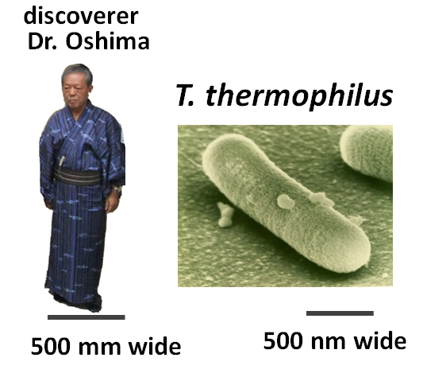
Fig. 1, Model Organism, Thermus thermophilus HB8

[1] Tairo Oshima and Kazutomo Imahori, Description of Thermus thermophilus (Yoshida and Oshima) comb. nov., a Nonsporulating Thermophilic Bacterium from a Japanese Thermal Spa, (1974), International Journal of Systematic and Evolutionary Microbiology 24: 102-112.
http://ijs.microbiologyresearch.org/content/journal/ijsem/10.1099/00207713-24-1-102

